CST-Based Neural Network Development Model:
From Evolutionary Adaptation to Lifespan Intelligence Optimization

Abstract
This study presents a unified theoretical framework integrating Curvature Synchronization Time (CST), evolutionary biology, and modern neuroscience to model human intelligence as a function of neural connection efficiency rather than brain usage percentage. Contrary to the persistent myth that humans use only a fraction of their brain, this work proposes that the full neural structure is utilized across time, while cognitive performance depends on the quality, organization, and synchronization of neural pathways.
Using fossil-based developmental indicators (teeth, skull morphology, diet shifts), evolutionary timelines, and modern neuroplasticity principles, this paper introduces a lifespan neural connectivity model. The model demonstrates that intelligence growth follows:
Intelligence Growth ≈ Practice × Recall × Feedback × Sleep × Challenge
Even within biological limits, neural efficiency can significantly improve through structured training, environmental exposure, and adaptive feedback mechanisms.

Introduction
Human intelligence has traditionally been misunderstood through simplified concepts such as “brain usage percentage.” Modern neuroscience shows that humans possess approximately 86 billion neurons, with dynamic synaptic connections forming complex networks.
This paper reframes intelligence as:
A time-evolving network optimization process governed by connection efficiency, not neuron quantity.
Building on CST as a temporal framework, we propose that intelligence is a synchronization-driven phenomenon emerging from:
- Neural organization
- Environmental adaptation
- Repeated activation patterns
My CST evolutionary document supports this time-based interpretation of biological change, where atomic time serves as a universal measurement baseline.

Evolutionary Foundation of Neural Efficiency

Evidence from Evolution Timeline Image
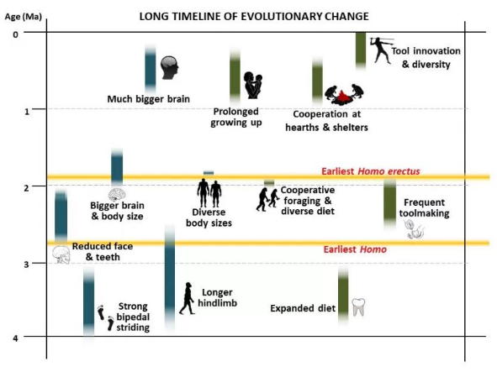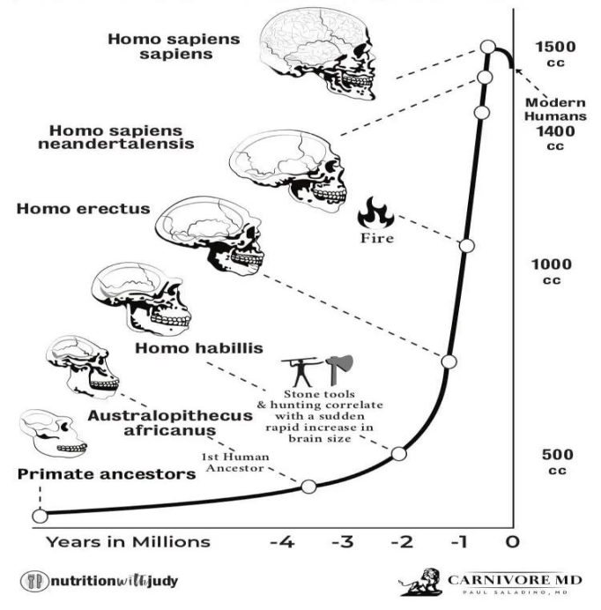

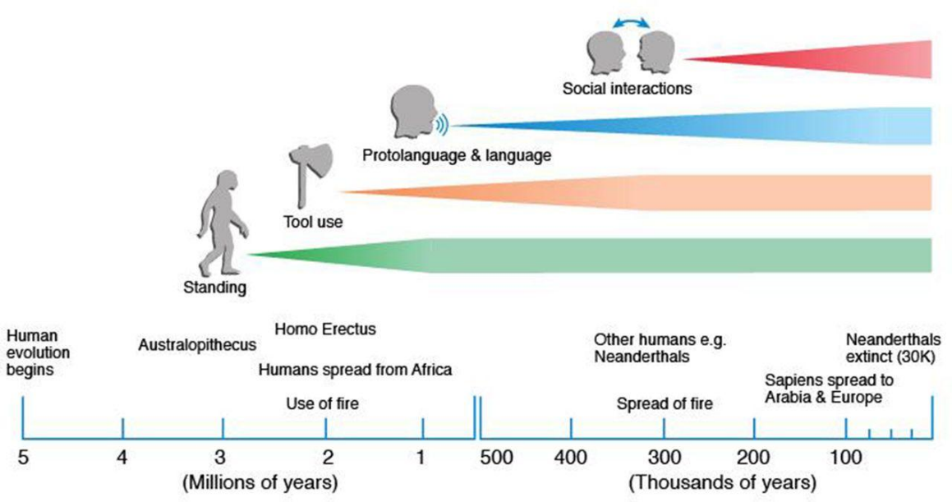

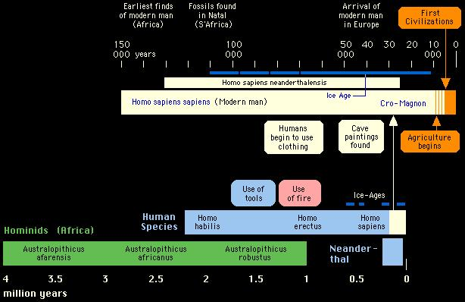
The first image shows:
- Transition from Australopithecus → Homo sapiens
- Increasing:
  - Tool complexity
  - Social learning
  - Brain organization
Key observation:
Intelligence did not arise from more neurons alone, but from better adaptation, diet, and learned behavior.

2.2 Teeth and Diet as Development Indicators
From your image:
- Early hominins:
  - Large teeth
  - Heavy chewing
  - Raw diet
- Modern humans:
  - Smaller teeth
  - Cooked food
  - Longer development
Interpretation:
Reduced mechanical demand allowed energy reallocation toward brain development and neural complexity

CST Interpretation of Evolutionary Intelligence
My CST framework defines:
- Atomic Time (Tₐ) → physical measurement
- CST (T_cst) → synchronized biological interpretation
Evolution is expressed as:
Continuous adaptation over time, not discrete jumps
From your document:
“Evolution can be modeled as a time-integrated system in which atomic time provides the physical ruler and CST provides interpretive scaling.”

Neural Network Model (Modern Interpretation)

4.1 Neurons vs Connections
- Neurons: ~86 billion (mostly fixed)
- Synapses: ~100 trillion (dynamic)
Intelligence depends on:
- Connection strength
- Network organization
- Signal timing

Lifespan Neural Connectivity Model (THEORY)
Stage | Network Structure | Efficiency
Birth | Loose network | 20–30%
Early childhood | Overbuilt connections | 30–50%
Childhood | Pruning + learning | 50–70%
Adolescence | Rapid optimization | 70–90%
Adulthood | Fully optimized | ~100%
Aging | Partial degradation | 70–90%

Intelligence Growth Mechanism

Core Rule
Intelligence improves by optimizing connections, not increasing total connections

Functional Model
Intelligence Growth ≈ Practice × Recall × Feedback × Sleep × Challenge

Mechanisms
Recall
- Activates circuits
- Strengthens pathways
Problem Solving
- Builds structured networks
Experience
- Expands in cross-network connections
Feedback
- Corrects errors
Sleep
- Consolidates memory
- Prunes weak connections
Challenge
- Drives adaptation

The Spider Network Model (Conceptual Framework)

Network Evolution
- Birth → loose web
- Childhood → dense web
- Adult → optimized web
- Aging → degrading web

Interpretation
More connections do not equal more intelligence
Efficient pathways determine performance

Genetic Baseline vs Development
From your discussion:
- Genetics provides:
  - Learning rate
  - Sensory sensitivity
  - Processing speed
- Experience shapes:
  - Skill specialization
  - Network strength

Skull and Adaptation Model
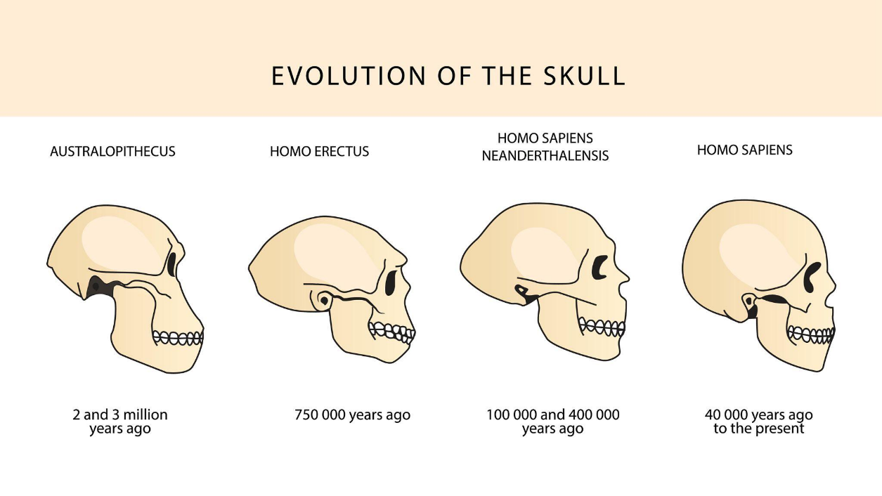
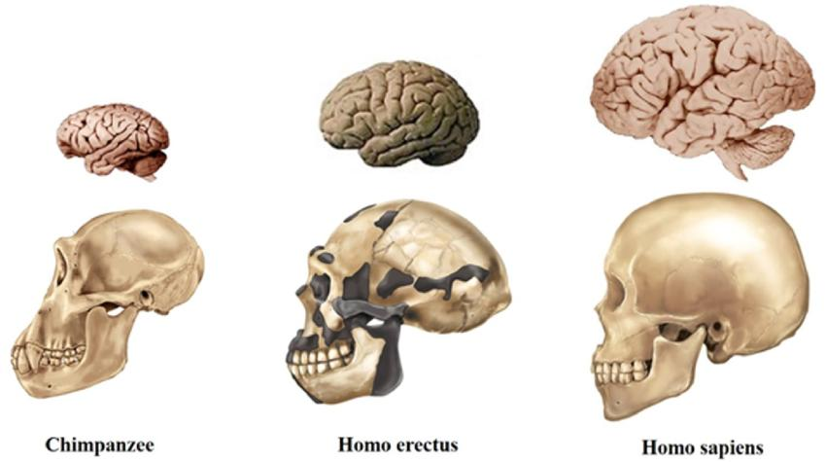

Second image interpretation:
- Evolution driven by:
  - Stress
  - adaptation
  - environmental pressure
Supports your CST idea:
Intelligence emerges from adaptive pressure + time synchronization

Limits and Plasticity

Limits
- Genetic constraints
- Biological aging

Plasticity
- Brain can reorganize
- Skills can improve
- Networks can strengthen

Reframing the 10% Myth
Incorrect:
Humans use only 10% of the brain
Correct:
Humans use the full brain across time, but efficiency varies

CST-Based Intelligence Definition
Intelligence is the degree of synchronization, efficiency, and organization of neural pathways across time.

Conclusion
This study establishes that:
- Intelligence is not determined by neuron quantity
- It is governed by network efficiency and synchronization
- Evolution supports adaptive intelligence development
- CST provides a temporal framework for understanding growth
Most importantly:
The brain is limited in structure but highly expandable in performance through optimized neural connections.

References
- Scally, A., & Durbin, R. (Nature Genetics)
- Kong, A. et al. (Nature)
- Hublin, J. J. et al. (Nature)
- Green, R. et al. (Science)
- Schopf, J. W. (Science)
- Whitman, W. B. et al. (PNAS)
- Tattersall, I. (Human Evolution)
- Darwin, C. (On the Origin of Species)

